

***Faculty of Science and Technology***

**Assignment Coversheet**

|  |  |
| --- | --- |
| **Student ID number &**  **Student Name** | u3261091  Oliver Davey |
| **Unit name** | Software Technology 1 |
| **Unit number** | 4483 |
| **Unit Tutor** | Ms. Linda Ma |
| **Assignment name** | ST1 Capstone Project – Semester 1 2023 |
| **Due date** | 12/5/2023 |
| **Date submitted** | 13/5/2023 |

**You must keep a photocopy or electronic copy of your assignment.**

**Student declaration**

I certify that the attached assignment is my own work. Material drawn from other sources has been appropriately and fully acknowledged as to author/creator, source and other bibliographic details.

**Signature of student: Oliver Davey Date: 12/5/2023**

Table of Contents

Introduction 1

Methodology 2

Stage 1: Algorithm Design Stage 2

Dataset Description 3

Exploratory Data Analysis 3

Predictive Data Analytics Stage 11

Model Preparation and Development 14

Stage 2: Algorithm Implementation Stage 22

Stage 3: Software Deployment Stage 22

Conclusions 23

References 23

# Introduction

This report was produced for the Software Technology 1 Unit Capstone Project. The capstone project requires the completion of an exploratory data analysis (EDA) and predictive data analysis (PDA) on a dataset of our choosing as described in the assignment specification document [1]. It then requires that we implement our predictive model into an application that predicts a target value. I decided to work with a New York Rental Property Pricing dataset from the Kaggle [2] online dataset repository.

New York rental properties consist of four main types: entire homes/apartments, private rooms, shared rooms, and hotel rooms. These four property types are widely distributed throughout New York City throughout different neighbourhoods with varying prices. Often a renter is going to pay more for privacy and a good location. Each property comes with specific requirements for property renting, such as the length of stay the renter will have. The property price’s, location, whether it’s shared or not and how highly regarded it is, normally correlate to what type of property you wish to rent.

A renter often has a limited amount of money they would be willing to pay for a rental property, they may also have an ideal location and property type in mind. Knowing this, the renter may want to know what property type their budget and preferences can get them. Therefore, it would be useful for potential renters to have access to an application that can determine what kind of property they may be looking at given certain variables including: price, location, how highly regarded by other renters the property is and the number of people who have rented the property. This service would aim to provide an accurate estimation at property types in the New York area based on user values who are looking to rent a property in any of New York’s neighbourhoods.

This report demonstrates the process of building a predictive software application and deploying it. It also aims to show the use of the effectiveness of Python for data analysis of a chosen dataset, through exploratory data analysis, predictive data analysis, Tkinter for algorithm development and the web application development tool Streamlit for the deployment of the application. The methodology details are shown in the following section.

# Methodology

To produce this software application there were multiple stages to complete, the method included these stages :

1. Design of predictive algorithm through exploratory and predictive data analysis
2. Implementation followed designing the algorithm using Tkinter, to make a GUI that uses the predictive algorithm.
3. Deployment of the implemented solution as a web-based platform with Streamlit

## Stage 1: Algorithm Design Stage

The algorithm design stage is vital to being able to produce an accurate user application. This is due to the algorithm being the driving factor behind prediction accuracy. To get the most accurate algorithm for the dataset an exploratory and predictive data analysis was required. To perform the analysis the dataset had to go through the following process:

1. Loading of the dataset
2. Checking that the loading was successful with basic exploratory data analysis questions.
3. Removing outliers from the dataset with the help of graphs for visual reference
4. Splitting cleaned data set into a training set and test set for predictive models
5. Formatting all attributes to numerical values to pre-process the data.
6. Building the models from SciKit-Learn algorithms.
7. Testing the models with our previously split dataset

### Dataset Description

The dataset used in this capstone project is available from Kaggle [2], an online data repository it was, authored by Ivan Chavez. It has 17614 unique observations, 11 attributes and a singular target class. The dataset attributes all correspond to a unique New York Rental property. These attributes include F1 (ID), id (ID), the neighbourhood of the property, the location (latitude and longitude), price, days occupied in 2019, the minimum nights to stay, number of reviews, reviews per month and availability in 2020. The chosen target attribute for the dataset is the room type. The room type can be one of four types, entire homes/apartments, private rooms, shared rooms, and hotels. The goal of this project is to use this dataset to deploy a New York rental property room type with a high level of accuracy, for prospective New York renters.

### Exploratory Data Analysis

As described above in the method section, stage 1 of producing the software involves an exploratory data analysis. An exploratory data analysis or EDA allows us to gain an understanding numerically and visually of the dataset that’s being worked with. To do this Google Collab an online notebook software was chosen for its ability to easily perform functions irrespective of the user’s computer performance capabilities due to it offering its own digital services. The language used in the notebook was Python, it was used to efficiently create graphs and data for the EDA with the use of several imported modules. These modules are included in the script below:

from google.colab import drive

drive.mount("/content/drive")

import os

import pandas as pd

import numpy as np

import matplotlib.pyplot as plt

import plotly.graph_objects as go

import plotly.express as px

import seaborn as sns

import warnings

# ignores warnings

warnings.filterwarnings("ignore")

# keeps all plots in the notebook screen

%matplotlib inline

# read the dataset

dataset = pd.read_csv('/content/drive/MyDrive/MyCapstoneProject/NY Realstate Pricing.csv')

The first steps of the EDA is to explore the dataset at a basic level, the steps shown below do this:

# look at first 5 observations

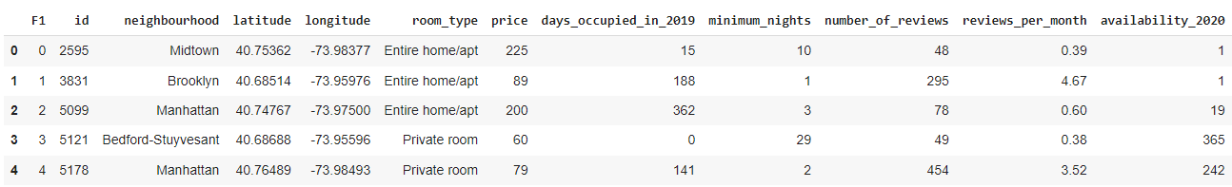dataset.head()

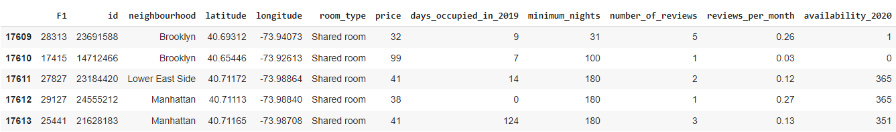dataset.tail() # looks at last 5 observations

#checking shape of dataset, makes sure it was imported properly

dataset.shape

(17614, 12)

# get attribute names

dataset.columns

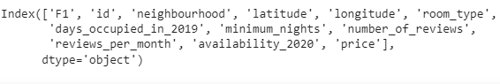

# find how many unique values there are in the data for each attribute

dataset.nunique()

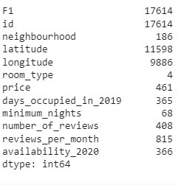

# info about attributes and types in dataset

dataset.info()

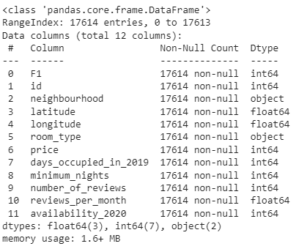

# Visualisation of data distribution

# creating subplots and setting plot sizes

figure = plt.figure(figsize = (30,30))

ax = figure.gca()

# accessing database and seperating values into 100 bins

dataset.hist(ax=ax, bins = 100, color = "darkblue")

# display the plots

plt.show()

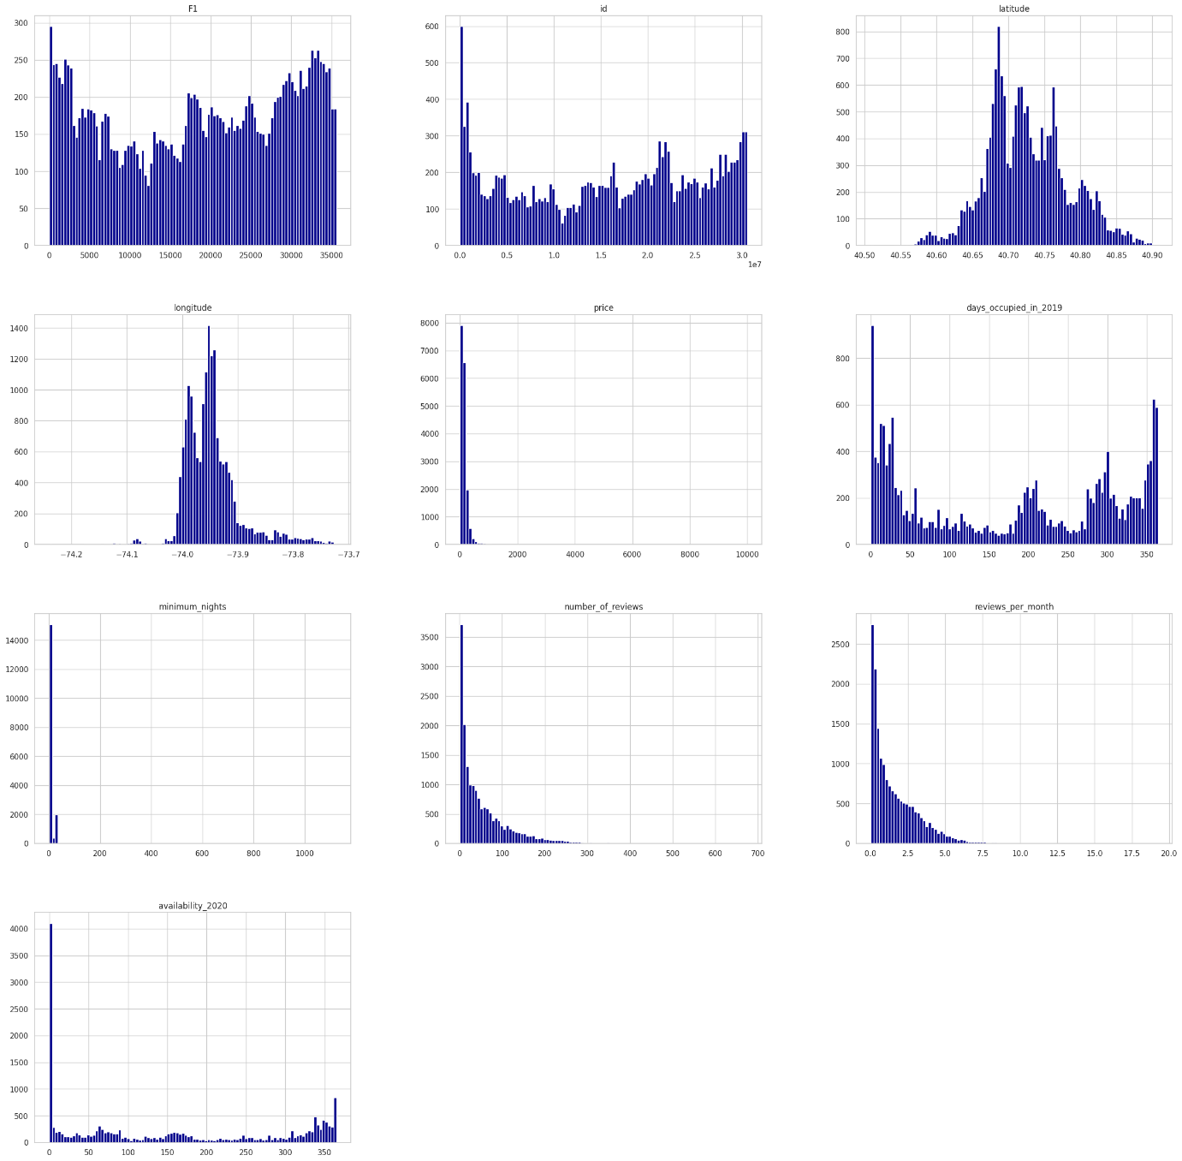

# showing outliers through boxplots

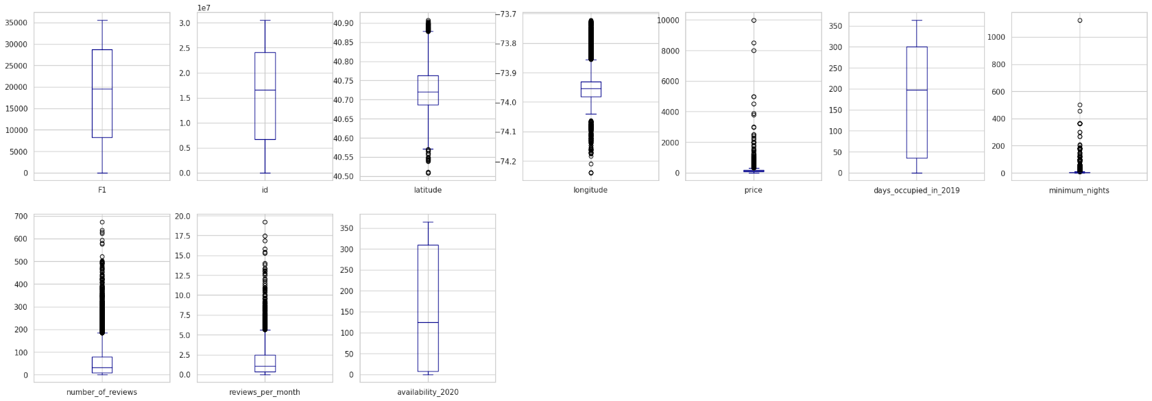dataset.plot(kind='box', subplots=True, layout=(2,7), figsize=(30, 10), color='darkblue');

# define outliers

outlier_list = ['price','minimum_nights','number_of_reviews','reviews_per_month']  # list of outliers

# detects and optionally removes outliers

def outliers(dataset_outliers, drop = False):

    for attribute in dataset_outliers.columns:

        # getting the outlier attribute data

        outlier_data = dataset_outliers[attribute]

        # getting first and third quartile of the outlier data

        Q1 = np.percentile(outlier_data, 25.)

        Q3 = np.percentile(outlier_data, 75.)

        interquartile_range = Q3-Q1

        # determining unacceptable values that are outside of range using constant

        out_acceptable = interquartile_range * 1.5 # 1.5 is a constant for finding outliers

        # subtracting the IQR*1.5 from Q1 to find bottom outliers, adding IQR*1.5 to Q2 to find top outliers

        attribute_outliers = outlier_data[~((outlier_data >= Q1 - out_acceptable) & (outlier_data <= Q3 + out_acceptable))].index.tolist()

        if not drop: # show outliers

            print(f"For the feature {attribute}, No of Outliers is {len(attribute_outliers)}")

        if drop: # remove the outliers from the attributes

            dataset.drop(attribute_outliers, inplace = True, errors = 'ignore')

            print(f"{attribute} outliers removed from dataset")

# show the outliers and the amount

outliers(dataset[outlier_list])

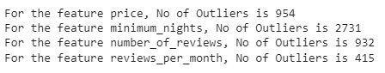

# remove outliers

outliers(dataset[outlier_list], drop = True)

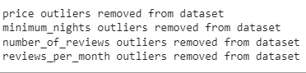

# checking the number of remaining outliers

outliers(dataset[outlier_list])

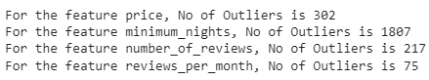

# visual check for outlier removal if outliers

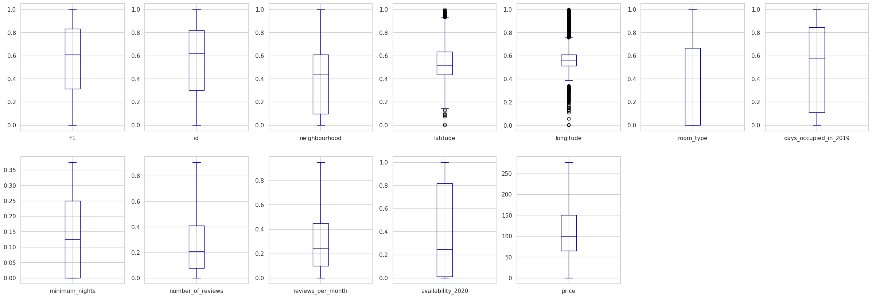dataset.plot(kind='box', subplots=True, layout=(2,7), figsize=(30, 10), color='darkblue');

# checking what data looks like after outlier removal

dataset.shape

(12913, 12)

# room type (target variable) distribution

sns.set(style = "whitegrid") # found style method in seaborn documentation https://seaborn.pydata.org/tutorial/aesthetics.html

# list of potential room types

room_types = ["Home/apt", "Private room", "Shared room", "Hotel room"]

# get data for graph

data = dataset.room_type.value_counts()

# create horizontal bar graph with matplotlib

# found graph in matplotlib documentation

# https://matplotlib.org/stable/api/_as_gen/matplotlib.axes.Axes.barh.html#matplotlib.axes.Axes.barh

ax = data.plot.barh(figsize=(10,6))

ax.set_title("Room Types For Rent")

#labels

ax.set_xlabel("Amount of Rooms")

ax.set_ylabel("Room Types")

ax.set_yticklabels(room_types)

plt.show()

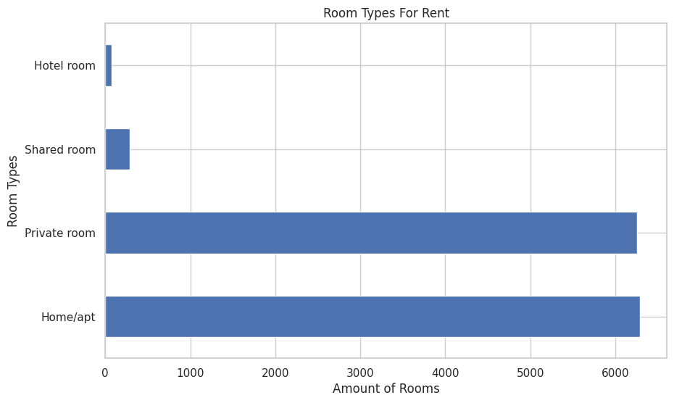

# visualisation of variable relationships with heatmap

# setting figure width, height

plt.figsize = (15, 10)

# create seaborn heatmap with values in squares

sns.heatmap(dataset.corr(), annot = True, cmap ="vlag") # colour found in seaborn documentation https://seaborn.pydata.org/tutorial/color_palettes.html

plt.title('NY Rental Property Attribute Correlation')

plt.show()

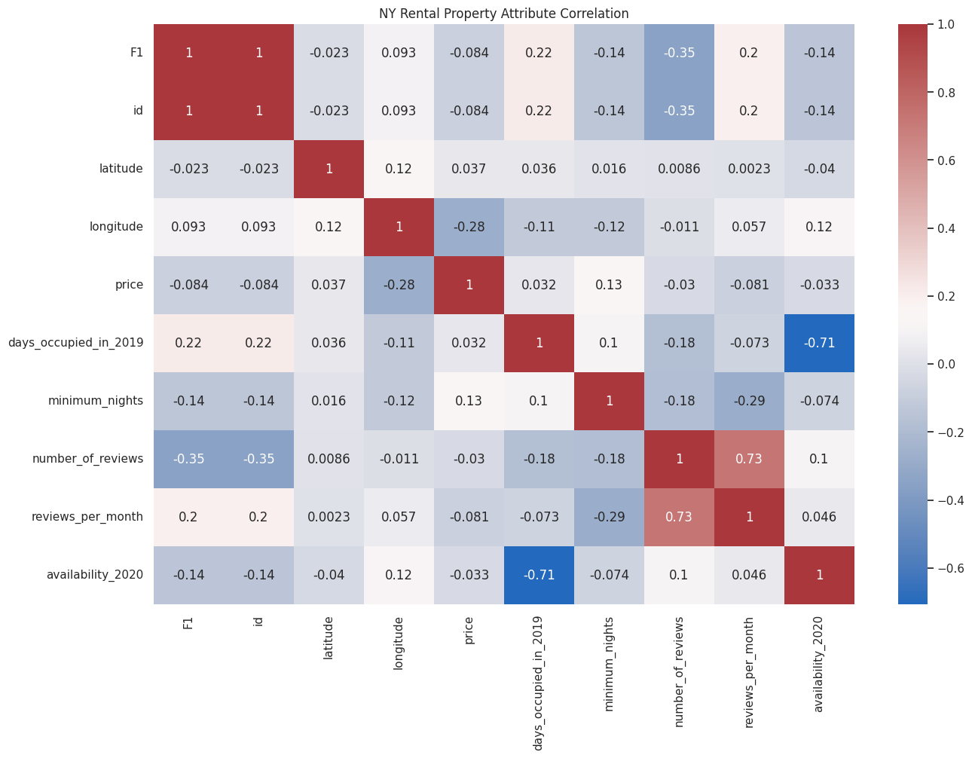

!pip install <https://github.com/pandas-profiling/pandas-profiling/archive/master.zip>

# profiler report to check against manual EDA

import pandas as pd

import numpy as np

from pandas_profiling import ProfileReport

# create profile

profile = ProfileReport(dataset,title="NYC Rental Property EDA", html={'style':{'full_width':True}})

profile.to_notebook_iframe()

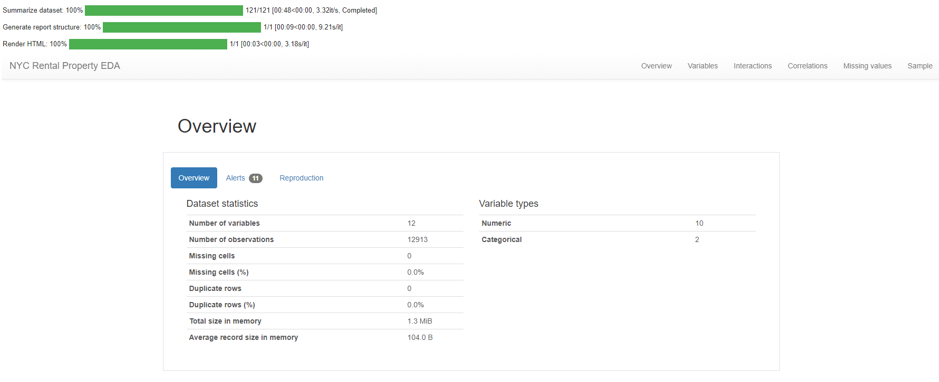

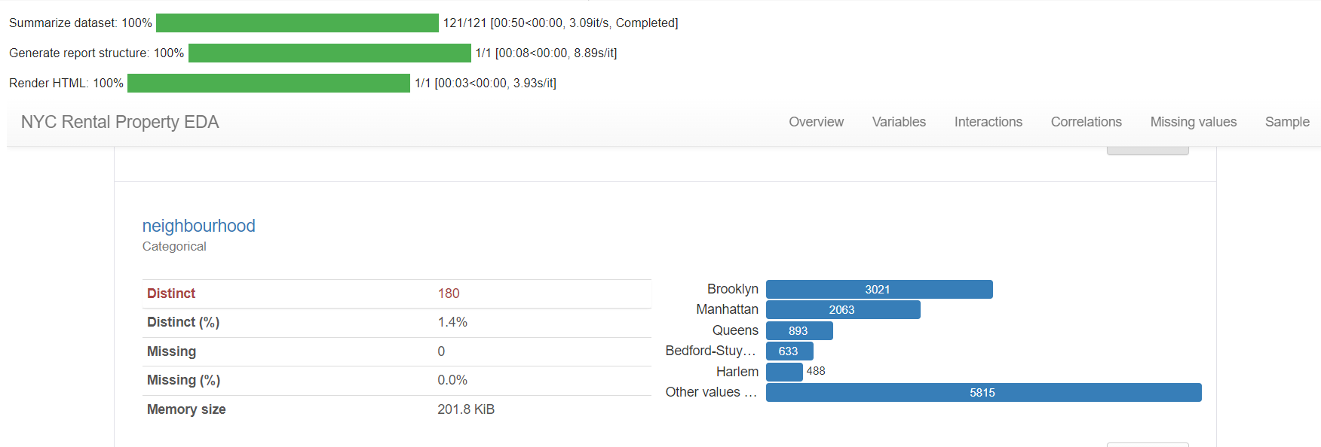

# Predictive Data Analytics Stage

The Predictive analysis of the NY Rental Properties involved numerus steps that aim to normalise data and process data before building a predictive algorithm. The first stage of the predictive analysis was to pre-process the data. This involves the use of a scikit-learn and its modules to make each attribute the same data type and standardise the data within the attribute. Next was normalisation of the data values which occurred in three parts, the removal of the target attribute from the dataset, the normalising and reattachment to the dataset. After the data was processed it could be used to train and test predictive models on its accuracy, precision, and recall abilities. The steps to pre-process are shown here:

# pre-processing data for prediction

from sklearn.exceptions import DataDimensionalityWarning

# encode object columns to integer values

from sklearn import preprocessing

from sklearn.preprocessing import OrdinalEncoder

for col in dataset:

    if dataset[col].dtype == "object":

        # reshaping attributes that are objects

        dataset[col]=OrdinalEncoder().fit_transform(dataset[col].values.reshape(-1,1))

dataset

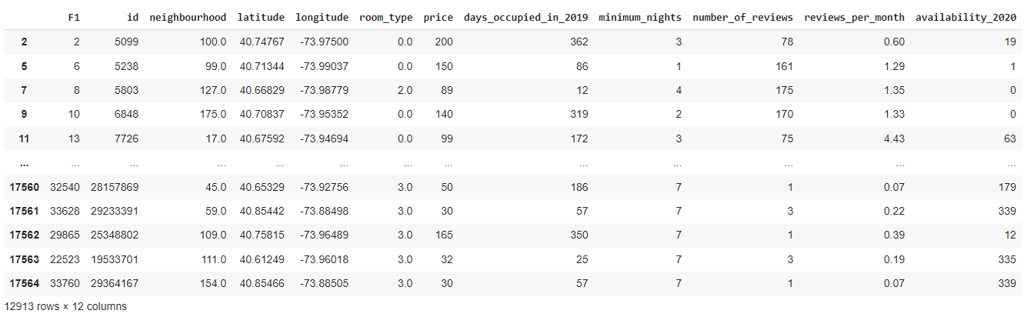

class_label = dataset['room_type']

dataset = dataset.drop(['room_type'], axis =1)

dataset = (dataset-dataset.min())/(dataset.max()-dataset.min())

dataset['room_type']=class_label

dataset

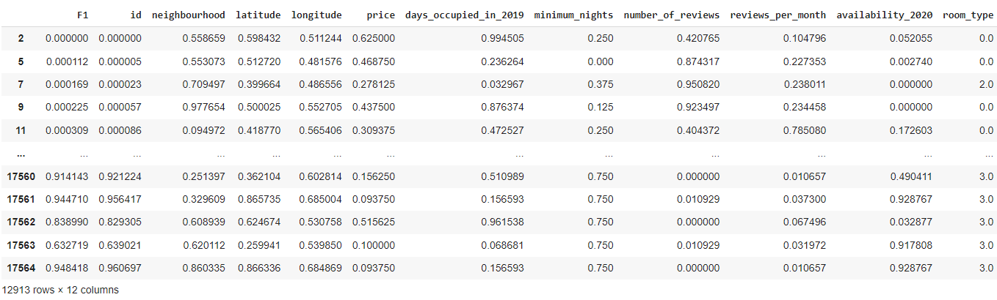

# pre-processing dataset for PDA

nyc_rental_data = dataset.copy()

le = preprocessing.LabelEncoder()

F1 = le.fit_transform(list(nyc_rental_data["F1"])) # identifier

id = le.fit_transform(list(nyc_rental_data["id"])) # identifier

neighbourhood = le.fit_transform(list(nyc_rental_data["neighbourhood"])) # location

latitude = le.fit_transform(list(nyc_rental_data["latitude"])) # location

longitude = le.fit_transform(list(nyc_rental_data["longitude"])) # location

days_occupied_in_2019 = le.fit_transform(list(nyc_rental_data["days_occupied_in_2019"]))

minimum_nights = le.fit_transform(list(nyc_rental_data["minimum_nights"]))

number_of_reviews = le.fit_transform(list(nyc_rental_data["number_of_reviews"]))

reviews_per_month = le.fit_transform(list(nyc_rental_data["reviews_per_month"]))

availability_2020 = le.fit_transform(list(nyc_rental_data["availability_2020"]))

price = le.fit_transform(list(nyc_rental_data["price"])) # price in USD

room_type = le.fit_transform(list(nyc_rental_data["room_type"])) # 4 types 0 = house, 1 = hotel, 2= private, 3 = shared

### Model Preparation and Development

## Steps used for machine learning model preparation are described below:

* + Split the data into two categories, testing and training. The training set takes 80% of the entire data leaving 20% for testing the trained model.
  + Separate the target attribute from the rest of the attributes in the training dataset.
  + Using the target class create the y_train
  + Using the remaining attributes form the x_train
  + Repeat the y_train and x_train creation for the test data as well.

# attributes used to predict target value

x = list(zip(neighbourhood, latitude, longitude, days_occupied_in_2019, minimum_nights, number_of_reviews, reviews_per_month, availability_2020, price))

# target value, room type

y = list(room_type)

num_folds = 5

seed = 7

# what the prediction is scored on

scoring = 'accuracy'

import sklearn.model_selection

# seperating dataset into test set (80%) and train set (20%)

x_train, x_test, y_train, y_test = sklearn.model_selection.train_test_split(x, y, test_size = 0.20, random_state=seed)

#size of train and test subsets after splitting

np.shape(x_train), np.shape(x_test)

((10330, 9), (2583, 9))

# modules from scikit learn to create a PDA, including predictive models

from sklearn.preprocessing import StandardScaler

from sklearn.model_selection import train_test_split

from sklearn.model_selection import KFold

from sklearn.model_selection import cross_val_score

from sklearn.model_selection import GridSearchCV

from sklearn.metrics import classification_report

from sklearn.metrics import confusion_matrix, ConfusionMatrixDisplay

from sklearn.metrics import accuracy_score

from sklearn.pipeline import Pipeline

from sklearn.linear_model import LogisticRegression

from sklearn.tree import DecisionTreeClassifier

from sklearn.neighbors import KNeighborsClassifier

from sklearn.discriminant_analysis import LinearDiscriminantAnalysis

from sklearn.naive_bayes import GaussianNB

from sklearn.svm import SVC

from sklearn.ensemble import AdaBoostClassifier

from sklearn.ensemble import GradientBoostingClassifier

from sklearn.ensemble import RandomForestClassifier

from sklearn.ensemble import ExtraTreesClassifier

# list of models used

predictive_models = []

# four models that will be tested for predictive accuracy

predictive_models.append(("NB", GaussianNB()))

predictive_models.append(("SVM", SVC()))

predictive_models.append(("RF", RandomForestClassifier()))

predictive_models.append(("GBM", GradientBoostingClassifier()))

model_results = []

model_names = []

print("Performance on Training set")

# go through model list and use each one

for name, model in predictive_models:

    kfold = KFold(n_splits=num_folds,shuffle=True,random_state=seed)

    cv_results = cross_val_score(model, x_train, y_train, cv=kfold, scoring="accuracy")

    # adding model name and accuracy to lists

    model_results.append(cv_results)

    model_names.append(name)

    # outputing results of model

    print(f"{name}: {cv_results.mean():,.6f} ({cv_results.std():,.6f})\n")

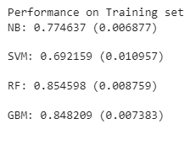

for i in range(len(model_names)):

  score = model_results[i] * 100

  print(f"{model_names[i]}: {score.mean():,.2f}% Accuracy")

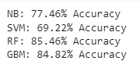

# comparing the predictive sklearn algorithms performance on the training set

fig = plt.figure()

fig.suptitle("Predictive Algorithm Comparison")

ax = fig.add_subplot(111)

plt.boxplot(model_results)

ax.set_xticklabels(model_names)

plt.show()

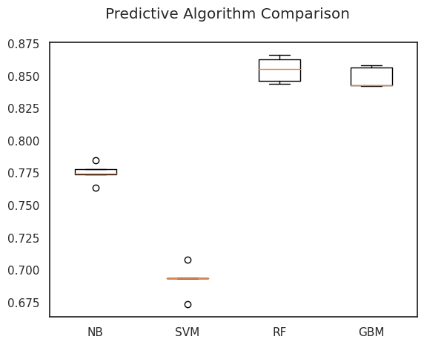

# Evaluating the best model, random forest classfier using the test dataset

models.append(('RF', RandomForestClassifier()))

randf = RandomForestClassifier()

best_model = randf

best_model.fit(x_train, y_train)

y_pred = best_model.predict(x_test)

print("Best Model Accuracy Score on Test Set:", accuracy_score(y_test, y_pred))



# classification report evaluation of best model

print(classification_report(y_test, y_pred))

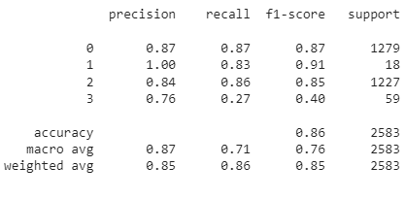

# confusion matrix evaluation report for best model

from sklearn.metrics import confusion_matrix, ConfusionMatrixDisplay

cm = confusion_matrix(y_test, y_pred)

display = ConfusionMatrixDisplay(confusion_matrix=cm)

display.plot()

plt.show()

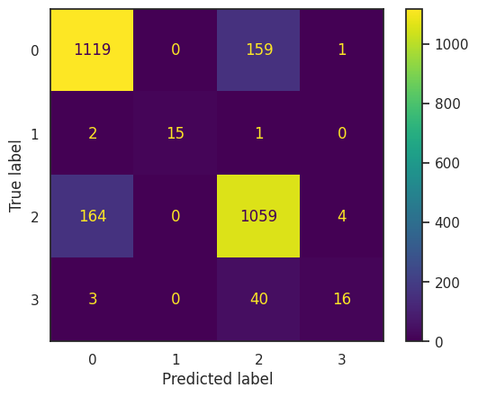

# prediction report for best model

for x in range(len(y_pred)): # too many values to look at so first 100 results are produced

  print(f"Predicted: {y_pred[x]} Actual: {y_test[x]} Data: {x_test[x]}")

(First 100 values, too many pages for the whole report)

|  |
| --- |
| Predicted: 2 Actual: 2 Data: (154, 8853, 7697, 207, 2, 51, 166, 154, 32)  Predicted: 0 Actual: 0 Data: (100, 4767, 1379, 361, 1, 18, 29, 1, 207)  Predicted: 2 Actual: 2 Data: (86, 6443, 7064, 85, 0, 19, 38, 328, 31)  Predicted: 2 Actual: 0 Data: (152, 5984, 6068, 52, 2, 0, 0, 330, 66)  Predicted: 2 Actual: 2 Data: (111, 382, 2911, 274, 1, 20, 108, 63, 36)  Predicted: 0 Actual: 0 Data: (93, 1216, 3426, 306, 2, 114, 279, 125, 82)  Predicted: 0 Actual: 2 Data: (65, 1905, 1631, 301, 2, 7, 42, 0, 86)  Predicted: 0 Actual: 0 Data: (17, 2820, 5579, 220, 1, 74, 501, 0, 181)  Predicted: 0 Actual: 2 Data: (105, 5731, 573, 74, 3, 179, 168, 296, 135)  Predicted: 2 Actual: 2 Data: (134, 7185, 7799, 290, 1, 23, 96, 66, 31)  Predicted: 2 Actual: 2 Data: (78, 8527, 3417, 335, 4, 2, 12, 0, 61)  Predicted: 0 Actual: 0 Data: (17, 1054, 2975, 282, 2, 1, 4, 83, 174)  Predicted: 2 Actual: 2 Data: (17, 5382, 3253, 26, 0, 23, 39, 308, 41)  Predicted: 2 Actual: 2 Data: (80, 8819, 5377, 8, 0, 172, 171, 0, 36)  Predicted: 0 Actual: 0 Data: (100, 8439, 3720, 357, 3, 70, 129, 0, 101)  Predicted: 0 Actual: 0 Data: (99, 4697, 1280, 356, 1, 0, 8, 0, 179)  Predicted: 0 Actual: 0 Data: (100, 4690, 1539, 288, 2, 163, 272, 33, 217)  Predicted: 2 Actual: 2 Data: (17, 2422, 3860, 16, 1, 32, 276, 321, 51)  Predicted: 0 Actual: 0 Data: (100, 8236, 3708, 357, 0, 2, 25, 0, 184)  Predicted: 2 Actual: 2 Data: (17, 910, 4886, 17, 2, 44, 255, 338, 41)  Predicted: 2 Actual: 2 Data: (10, 3075, 4036, 286, 0, 8, 58, 90, 26)  Predicted: 2 Actual: 2 Data: (55, 1058, 3248, 287, 0, 83, 216, 57, 38)  Predicted: 0 Actual: 0 Data: (38, 1950, 2979, 202, 2, 123, 261, 144, 135)  Predicted: 2 Actual: 2 Data: (17, 2242, 6741, 56, 5, 14, 85, 155, 28)  Predicted: 0 Actual: 0 Data: (151, 459, 9, 280, 2, 21, 52, 146, 126)  Predicted: 0 Actual: 2 Data: (151, 381, 48, 247, 0, 44, 337, 0, 66)  Predicted: 0 Actual: 2 Data: (10, 3272, 5078, 289, 0, 80, 390, 74, 86)  Predicted: 0 Actual: 0 Data: (17, 2596, 1874, 15, 0, 6, 32, 278, 242)  Predicted: 2 Actual: 0 Data: (134, 3316, 7556, 214, 6, 2, 37, 0, 37)  Predicted: 2 Actual: 2 Data: (17, 3707, 6198, 11, 1, 43, 137, 346, 15)  Predicted: 0 Actual: 0 Data: (151, 536, 121, 214, 3, 135, 422, 124, 61)  Predicted: 0 Actual: 0 Data: (175, 4557, 4485, 297, 1, 49, 398, 67, 159)  Predicted: 0 Actual: 0 Data: (45, 825, 5298, 267, 2, 29, 178, 91, 111)  Predicted: 0 Actual: 2 Data: (3, 6769, 5726, 349, 3, 20, 160, 23, 66)  Predicted: 0 Actual: 0 Data: (17, 3160, 5854, 312, 4, 24, 207, 0, 160)  Predicted: 2 Actual: 2 Data: (17, 1255, 7039, 185, 2, 17, 97, 180, 37)  Predicted: 2 Actual: 2 Data: (78, 7863, 4674, 31, 1, 108, 377, 340, 68)  Predicted: 2 Actual: 2 Data: (154, 9038, 6869, 278, 2, 25, 62, 0, 27)  Predicted: 0 Actual: 2 Data: (99, 4589, 1594, 144, 4, 24, 38, 193, 155)  Predicted: 2 Actual: 2 Data: (163, 9169, 6523, 9, 2, 29, 98, 355, 26)  Predicted: 0 Actual: 0 Data: (134, 2374, 7860, 18, 1, 40, 293, 351, 150)  Predicted: 0 Actual: 0 Data: (21, 2745, 6267, 91, 2, 93, 164, 297, 207)  Predicted: 2 Actual: 2 Data: (17, 1621, 3329, 312, 0, 72, 455, 64, 56)  Predicted: 3 Actual: 2 Data: (100, 9004, 4602, 84, 2, 36, 130, 286, 11)  Predicted: 0 Actual: 0 Data: (139, 9393, 6848, 170, 5, 8, 29, 213, 140)  Predicted: 2 Actual: 2 Data: (22, 604, 6569, 190, 0, 89, 292, 79, 36)  Predicted: 2 Actual: 2 Data: (17, 2998, 4985, 226, 3, 6, 45, 126, 61)  Predicted: 0 Actual: 0 Data: (3, 6955, 6181, 360, 2, 5, 40, 0, 111)  Predicted: 1 Actual: 1 Data: (17, 3091, 3442, 6, 0, 15, 99, 364, 23)  Predicted: 0 Actual: 0 Data: (17, 2013, 3674, 306, 2, 5, 17, 59, 86)  Predicted: 2 Actual: 2 Data: (17, 1296, 1269, 22, 1, 63, 370, 348, 41)  Predicted: 2 Actual: 2 Data: (155, 171, 8209, 149, 5, 5, 11, 287, 24)  Predicted: 2 Actual: 2 Data: (100, 5842, 1984, 349, 2, 6, 55, 0, 85)  Predicted: 0 Actual: 0 Data: (17, 4459, 4658, 270, 2, 35, 189, 141, 207)  Predicted: 0 Actual: 0 Data: (100, 3819, 429, 353, 4, 51, 256, 229, 140)  Predicted: 2 Actual: 2 Data: (100, 6037, 1842, 358, 0, 13, 91, 0, 75)  Predicted: 0 Actual: 0 Data: (43, 383, 365, 43, 1, 67, 279, 344, 86)  Predicted: 2 Actual: 2 Data: (55, 1325, 3810, 112, 1, 91, 381, 214, 46)  Predicted: 2 Actual: 2 Data: (48, 4751, 2146, 217, 3, 152, 229, 142, 71)  Predicted: 2 Actual: 2 Data: (134, 3804, 6693, 215, 0, 37, 96, 2, 31)  Predicted: 0 Actual: 2 Data: (110, 6665, 2660, 176, 2, 82, 180, 334, 179)  Predicted: 0 Actual: 0 Data: (100, 4742, 1348, 324, 3, 105, 241, 144, 191)  Predicted: 2 Actual: 2 Data: (175, 4117, 2782, 19, 1, 68, 409, 349, 96)  Predicted: 2 Actual: 2 Data: (61, 2983, 2363, 15, 1, 171, 165, 335, 81)  Predicted: 2 Actual: 0 Data: (38, 1679, 4470, 239, 0, 27, 243, 55, 66)  Predicted: 2 Actual: 0 Data: (17, 1948, 4941, 122, 6, 116, 135, 330, 68)  Predicted: 2 Actual: 2 Data: (78, 8551, 3507, 146, 2, 16, 25, 279, 46)  Predicted: 0 Actual: 2 Data: (138, 3607, 6491, 6, 6, 13, 21, 328, 86)  Predicted: 0 Actual: 0 Data: (21, 3396, 5318, 332, 2, 6, 31, 66, 96)  Predicted: 2 Actual: 2 Data: (134, 5967, 6033, 42, 0, 106, 481, 316, 46)  Predicted: 0 Actual: 0 Data: (100, 5585, 656, 357, 0, 49, 205, 35, 207)  Predicted: 0 Actual: 0 Data: (17, 1265, 6856, 245, 3, 177, 329, 63, 55)  Predicted: 0 Actual: 0 Data: (175, 4175, 2652, 321, 2, 19, 73, 32, 165)  Predicted: 0 Actual: 2 Data: (100, 7880, 3445, 278, 1, 14, 22, 0, 130)  Predicted: 2 Actual: 2 Data: (17, 2602, 6112, 28, 1, 70, 162, 339, 46)  Predicted: 0 Actual: 0 Data: (26, 4269, 1214, 359, 2, 52, 103, 112, 155)  Predicted: 0 Actual: 0 Data: (45, 1039, 5864, 11, 3, 84, 164, 354, 125)  Predicted: 2 Actual: 2 Data: (140, 6682, 4029, 360, 2, 33, 128, 326, 71)  Predicted: 2 Actual: 2 Data: (61, 2735, 2273, 25, 4, 3, 13, 218, 85)  Predicted: 0 Actual: 0 Data: (10, 2907, 3653, 205, 2, 158, 444, 0, 96)  Predicted: 2 Actual: 0 Data: (100, 8398, 3718, 69, 0, 43, 165, 0, 116)  Predicted: 2 Actual: 2 Data: (133, 2124, 2455, 270, 0, 58, 434, 0, 41)  Predicted: 2 Actual: 2 Data: (17, 420, 5212, 57, 0, 8, 21, 338, 31)  Predicted: 2 Actual: 2 Data: (79, 6606, 1170, 195, 0, 82, 514, 254, 96)  Predicted: 2 Actual: 2 Data: (10, 2849, 3698, 210, 1, 36, 140, 133, 76)  Predicted: 2 Actual: 2 Data: (17, 3782, 4894, 10, 1, 44, 272, 355, 66)  Predicted: 0 Actual: 2 Data: (17, 2287, 7185, 204, 1, 65, 353, 339, 85)  Predicted: 2 Actual: 2 Data: (17, 1562, 6395, 0, 2, 3, 25, 365, 106)  Predicted: 2 Actual: 2 Data: (100, 9088, 5394, 190, 3, 42, 285, 147, 56)  Predicted: 2 Actual: 2 Data: (100, 7278, 4024, 295, 0, 135, 410, 166, 112)  Predicted: 2 Actual: 0 Data: (38, 2043, 4286, 231, 2, 1, 3, 222, 56)  Predicted: 0 Actual: 0 Data: (134, 6489, 6153, 96, 2, 87, 141, 258, 165)  Predicted: 0 Actual: 0 Data: (17, 2634, 4624, 197, 1, 43, 61, 41, 136)  Predicted: 2 Actual: 0 Data: (55, 1001, 3466, 330, 1, 0, 5, 5, 51)  Predicted: 2 Actual: 2 Data: (134, 6436, 7920, 192, 1, 27, 131, 177, 32)  Predicted: 0 Actual: 2 Data: (17, 2987, 1095, 343, 3, 7, 58, 0, 84)  Predicted: 2 Actual: 3 Data: (55, 971, 3799, 327, 1, 71, 258, 54, 34)  Predicted: 0 Actual: 0 Data: (17, 1971, 2660, 197, 3, 13, 17, 158, 179)  Predicted: 2 Actual: 2 Data: (17, 918, 399, 360, 6, 12, 22, 0, 26)  Predicted: 2 Actual: 2 Data: (175, 4335, 4780, 0, 3, 11, 15, 365, 121) |

## 

## Stage 2: Algorithm Implementation Stage

Using my best performing algorithm for the NY Rental Property Prices dataset, which was the Random Forest Classifier, implement it using the TKinter Python module to make a GUI. Then use Streamlit to then deploy the implemented solution.

After performing the EDA and PDA to identify the best room type predictive algorithm and model in the first stage of the capstone project. Tkinter is used to implement a graphical user interface for the model.

The EDA, PDA and Tkinter PyCharm Project can be found at this GitHub repo link:

## <https://github.com/Zuccubus/SFTW1CapProject>

## Testing:

## Input: (Brooklyn (0), 40.68514, -73.95976, 188 ,1 , 295, 4.67, 1, 89),

## associated room_type = Entire house/apt

## Expected: Entire house/apt

## Output: Entire home/apt, this a correct prediction based on the row used for the test

## 

## Reflection:

## The application worked as designed, it correctly predicted the room type of a known row.

## I choose to limit selectable list containing the possible neighbourhoods to the 5 main neighbourhoods. Both to make implementation possible and make the application easy to use for others, this also didn’t appear to affect the outcome of the prediction.

## Stage 3: Software Deployment Stage

The last stage is the Deployment stage, and it involves using the Streamlit to deploy the algorithm. This is done after stages 1, with the EDA and PDA, and stage 2 which implements the algorithm designed in stage 1. This is required for ease of access as the Tkinter application is stored locally and unavailable to people who might be interested in using the model.

The Deployed model can be found at this GitHub repo link:

## <https://github.com/Zuccubus/SFTW1CapProject>

For the deployment to work it must follow these steps:

1. Import Streamlit and predictive model.
2. Get input for all non-target attributes using Streamlit input modules.
3. Process the input by assigning numerical values to object type attributes.
4. Give the best model a list of all inputted attributes to predict a room type.
5. Output the room type.

## Testing:

## Input: (Bedford-Stuyvesant (4), 40.68682, -73.95653, 0, 3, 49, 0.38, 365, 60)

## Output: Private room

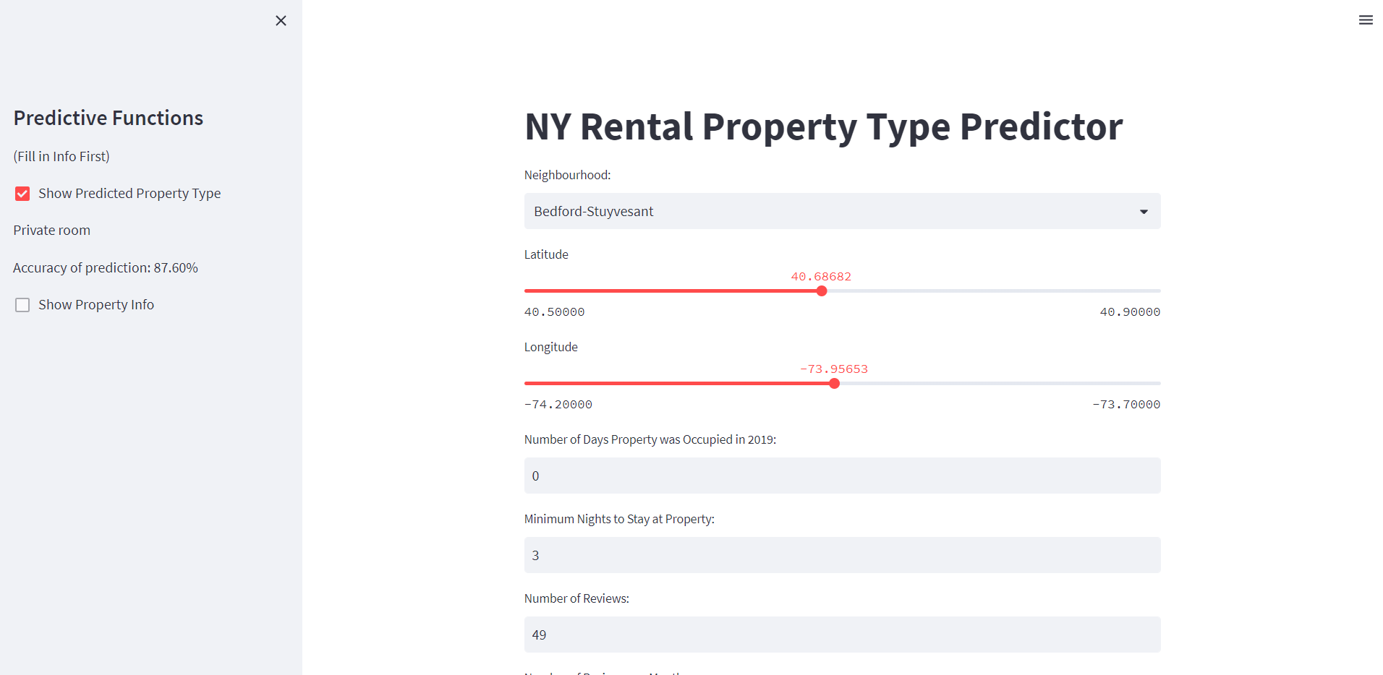

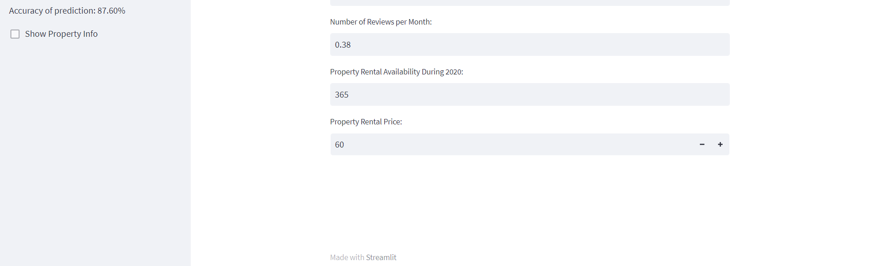

## Reflection:

* The deployed application was able to make a prediction of the room type.
* All input functions worked as desired, although the use of sliders for latitude and longitude did make it harder to accurately input location.

# Conclusion

The report provides wholistic insight into the process of predictive algorithm design through exploratory and predictive data analysis, the implementation of the algorithm into a user-friendly application and the deployment of the model. The purpose of my project was to help New York resident who are hoping to rent a property, see what property/room type they would be able to get. This can help renters set goals and choose locations accordingly to their preference of room type and living condition. The project was successful in fulfilling its purpose in all stages of algorithm development, implementation and deployment as the final product was a web-based tool that successful offered a prediction of room type based on certain variables.

## References

1. <https://uclearn.canberra.edu.au/courses/13571/assignments/105232>
2. <https://www.kaggle.com/datasets/ivanchvez/ny-rental-properties-pricing>
3. <https://seaborn.pydata.org/tutorial/color_palettes.html>
4. <https://seaborn.pydata.org/tutorial/aesthetics.html>
5. <https://matplotlib.org/stable/api/_as_gen/matplotlib.axes.Axes.barh.html#matplotlib.axes.Axes.barh>
6. <https://docs.streamlit.io/library/api-reference>